**Coastal Groove Festival - Supporting Documentation**

1. **Different pages of the website:**

The website I created is the Coastal Groove Festival website. It has six different webpages.Every page I showcase will be with its’ lower parts in order of viewing.

Firstly, the landing home page that displays on localhost:5000 when the viewer first enters the website: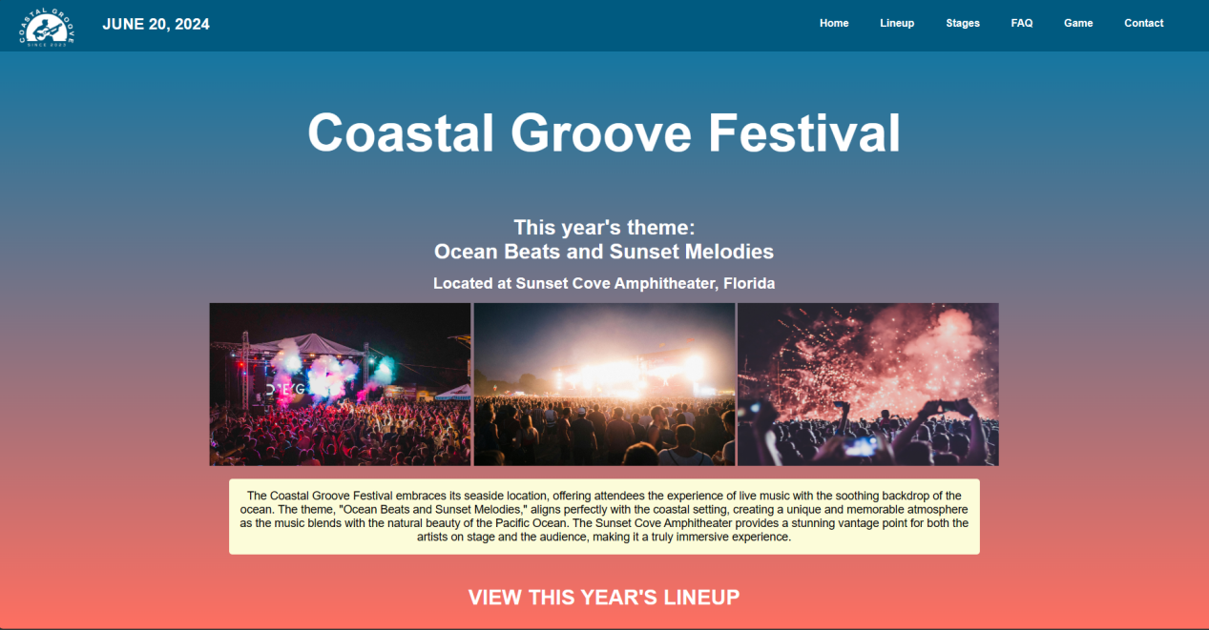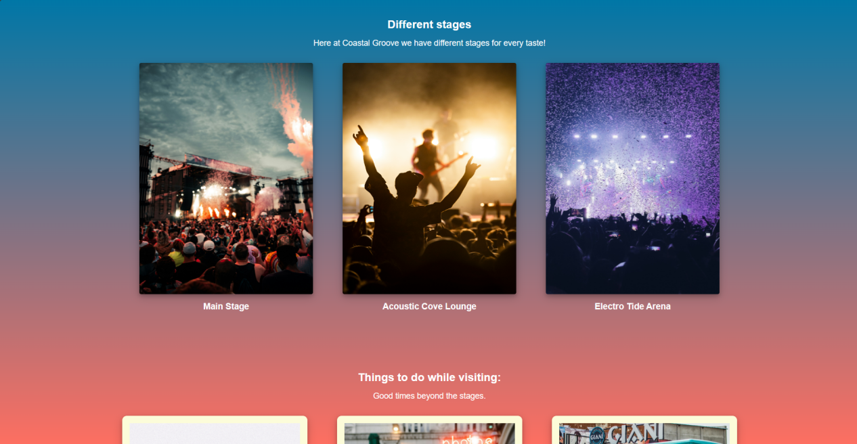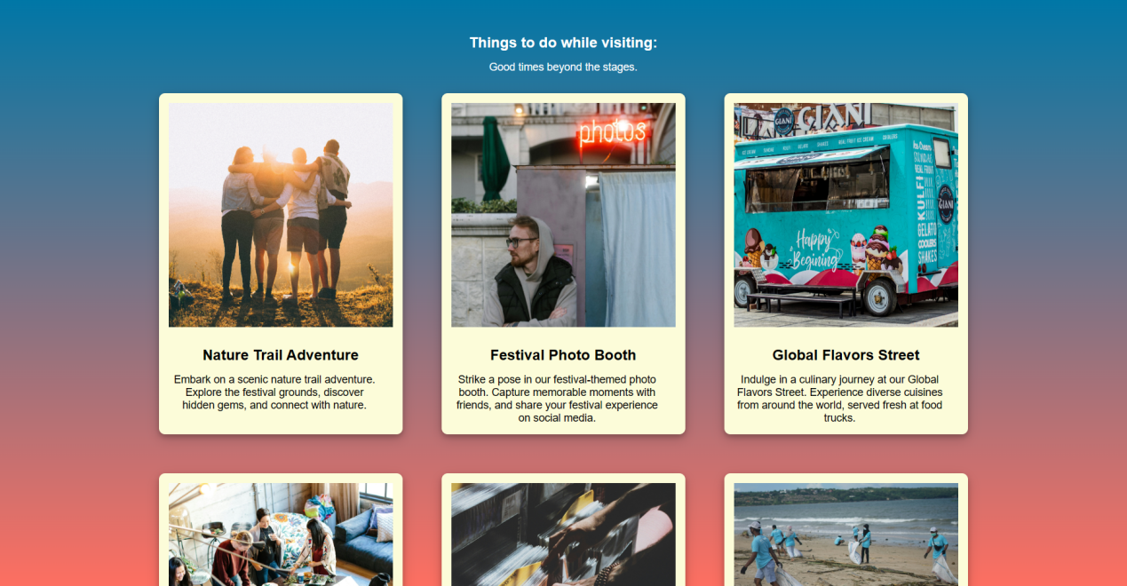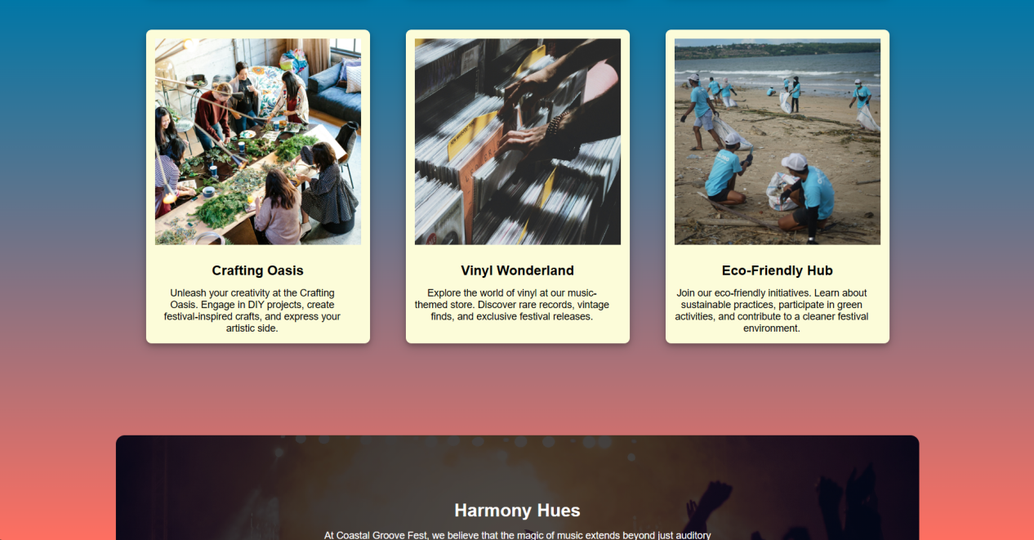

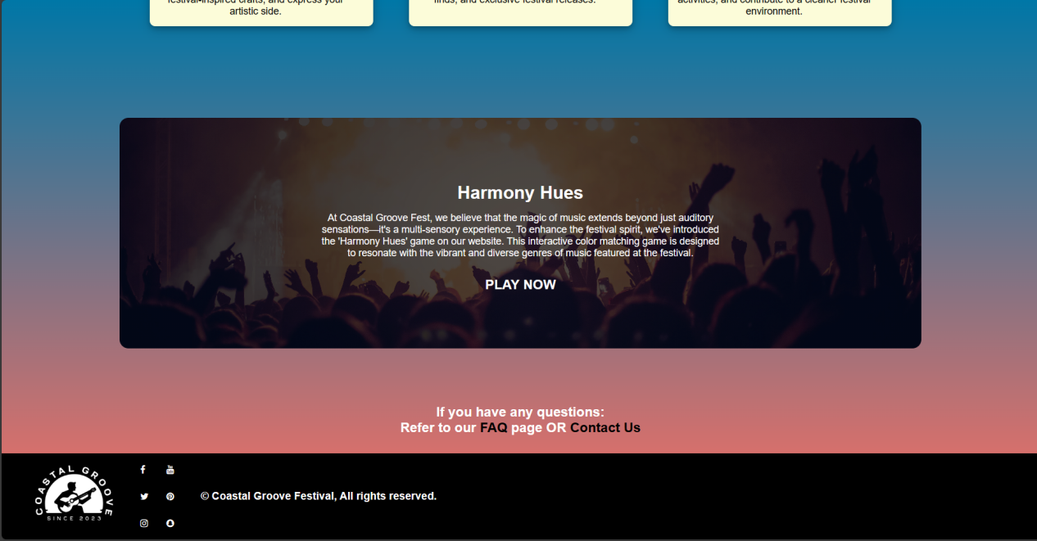

**Then we have the page with this year’s lineup on localhost:5000/lineup**

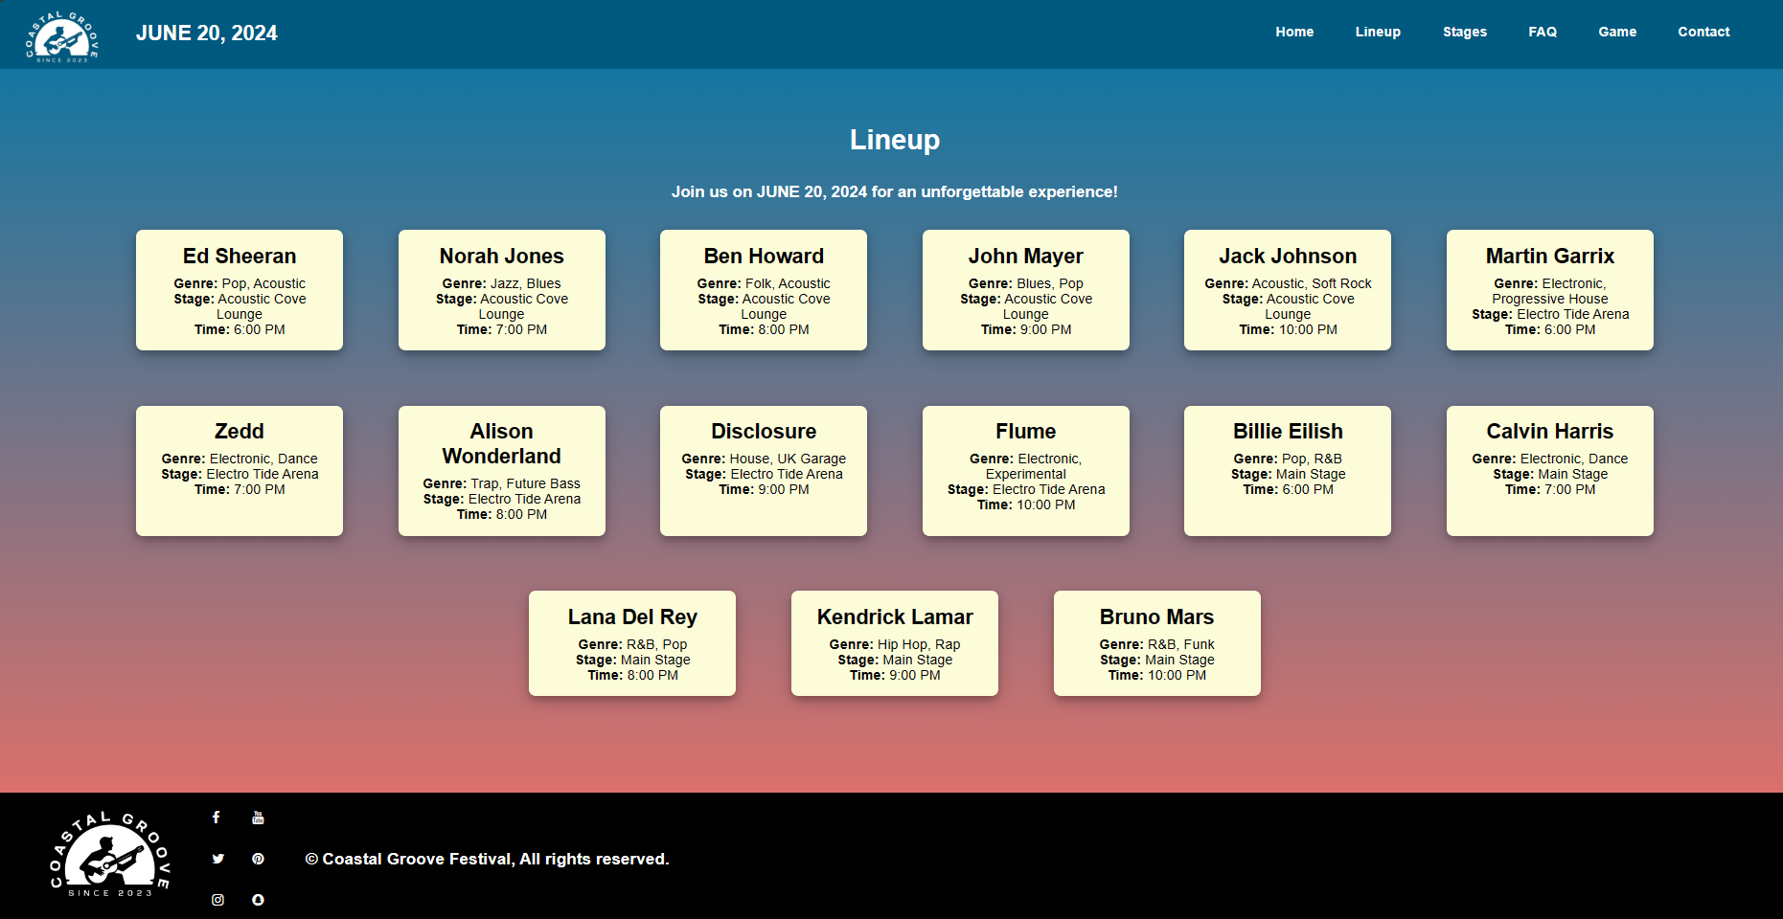

**The page with the different kinds of stages at localhost:5000/stages**

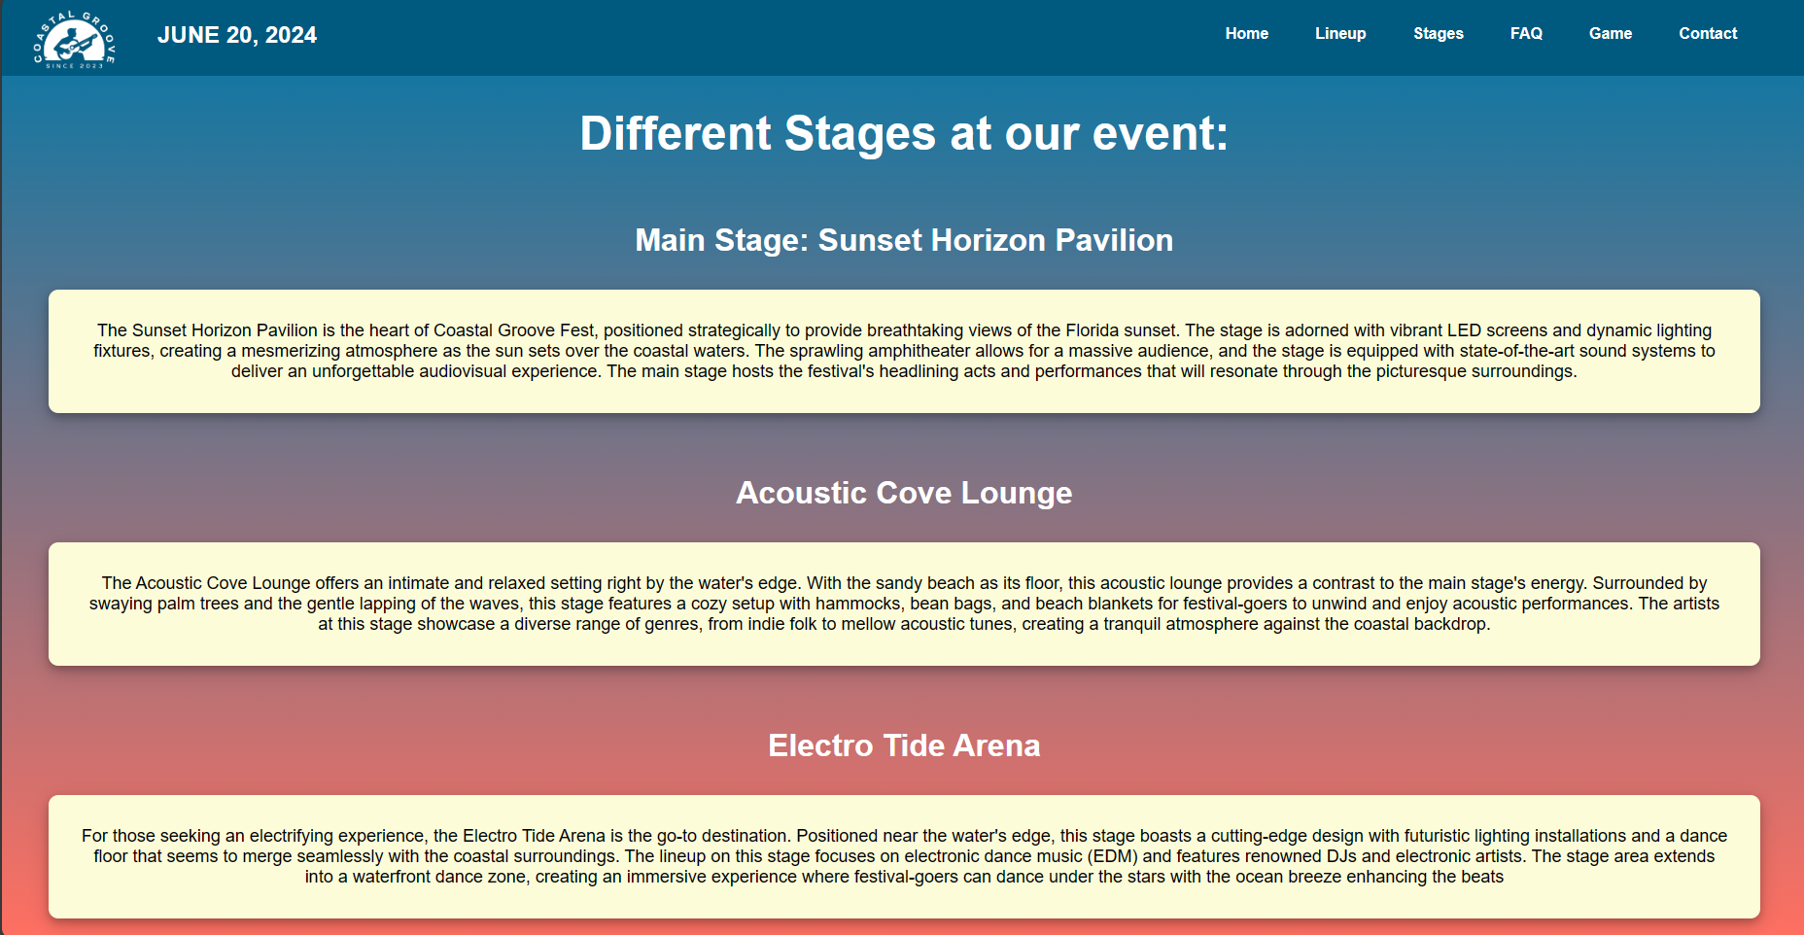

**The FAQ page at localhost:5000/faq**

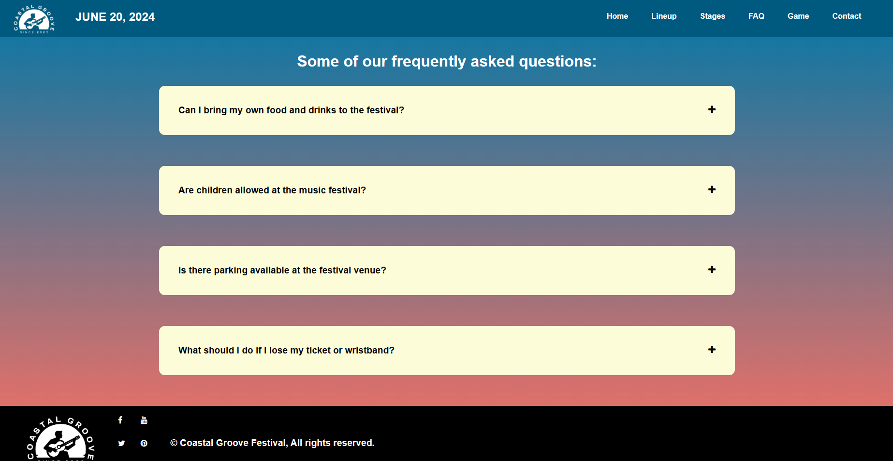

**And the same page with the answers to the questions revealed:**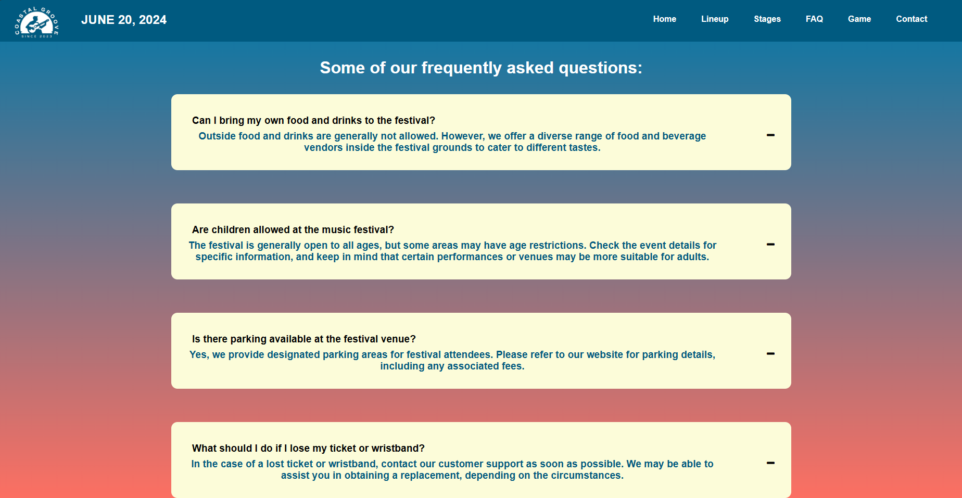

**The page with the activity required for the B grade, in my case a color matching game at localhost:5000/activity**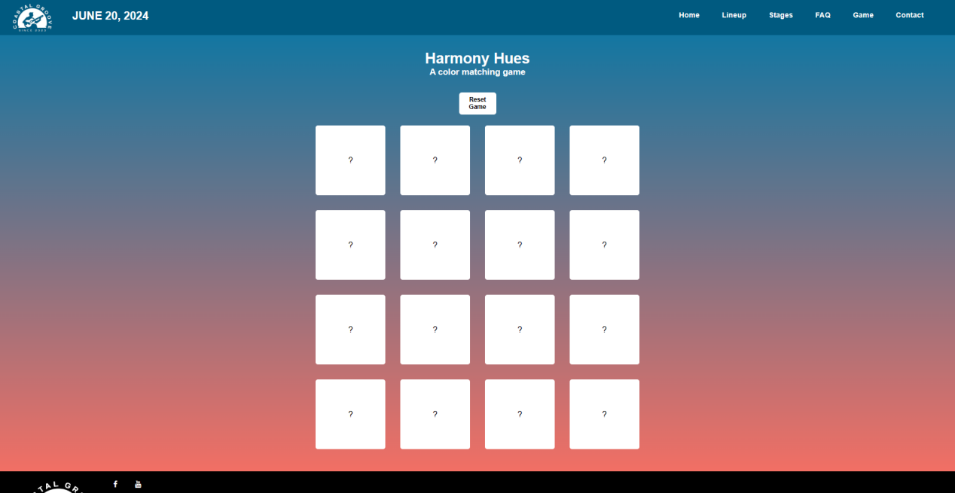

**The same page with half of the game completed:**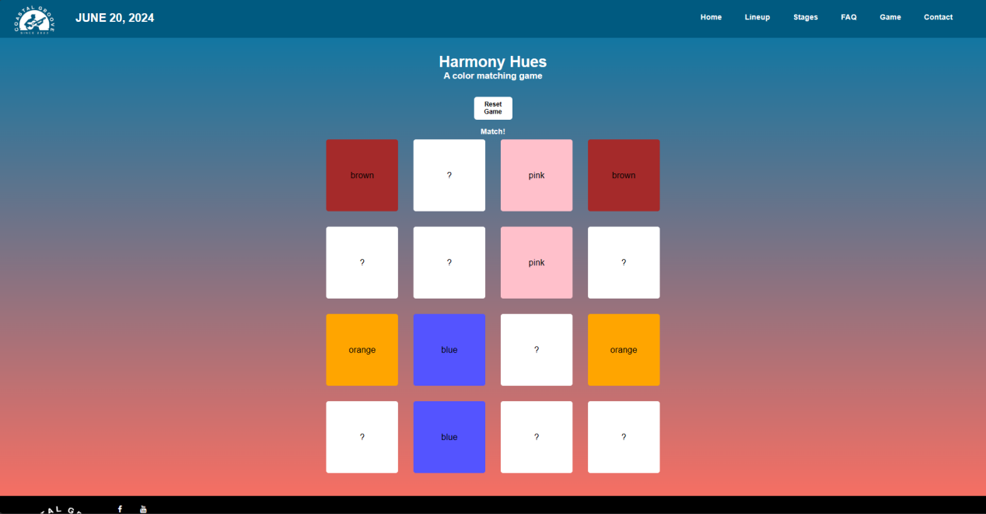

**And the page with the whole game being completed by the user:**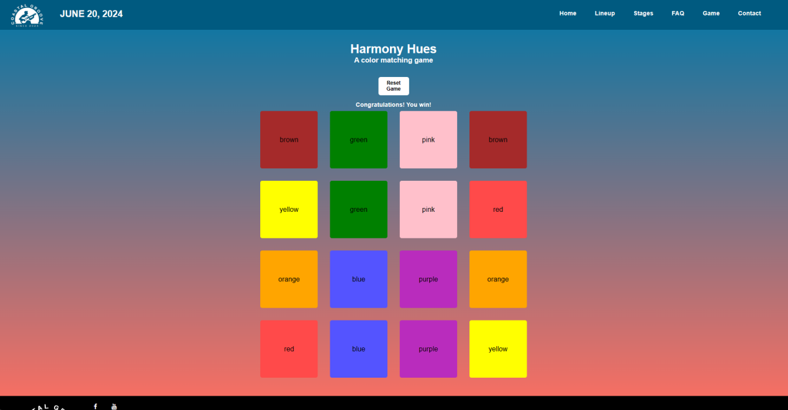

**And the contact page of the website at localhost:5000/contact**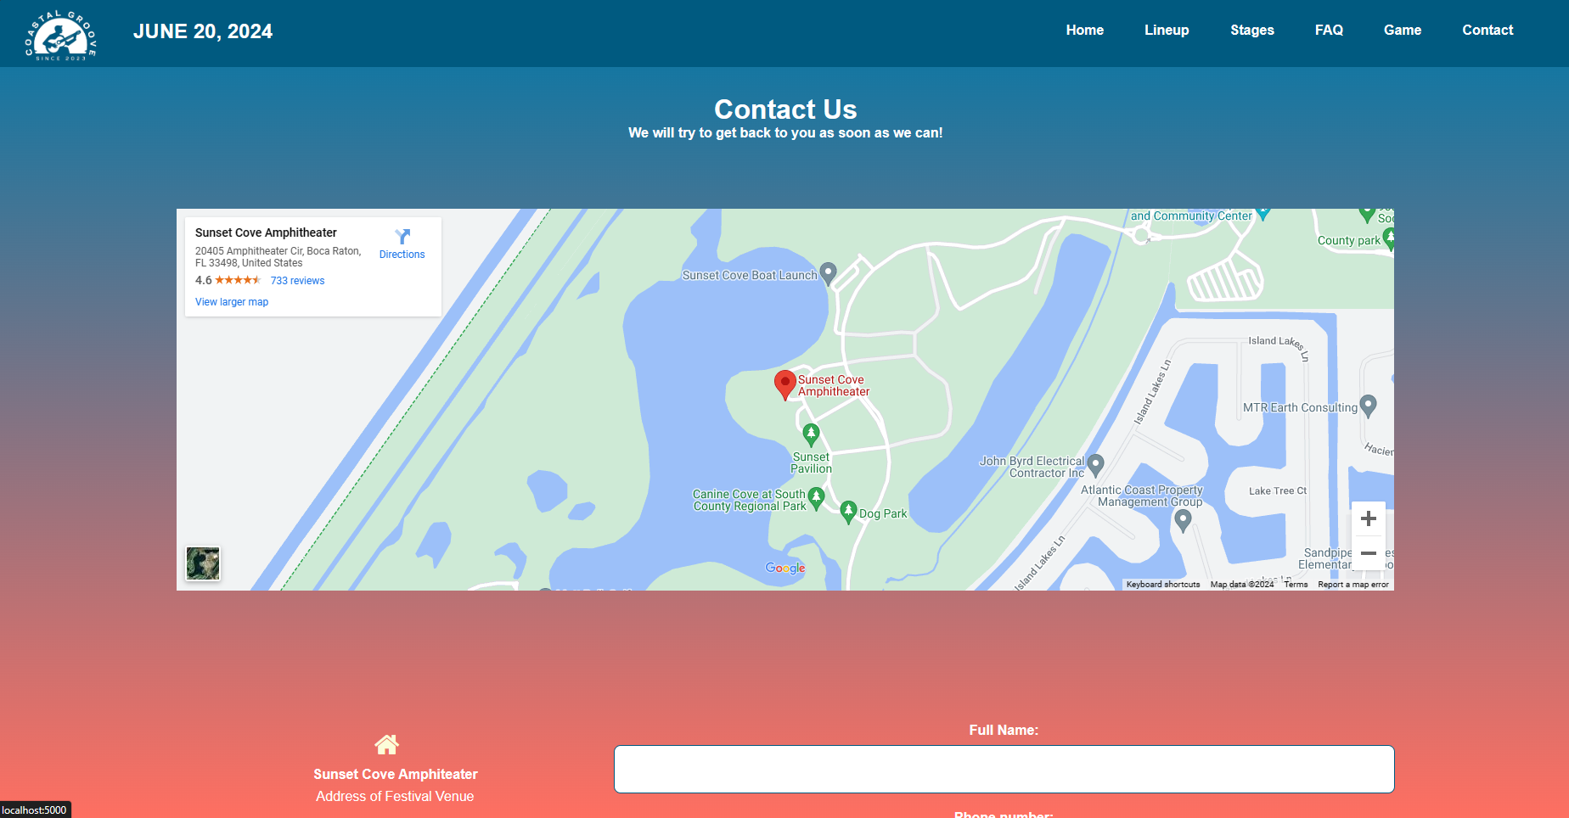

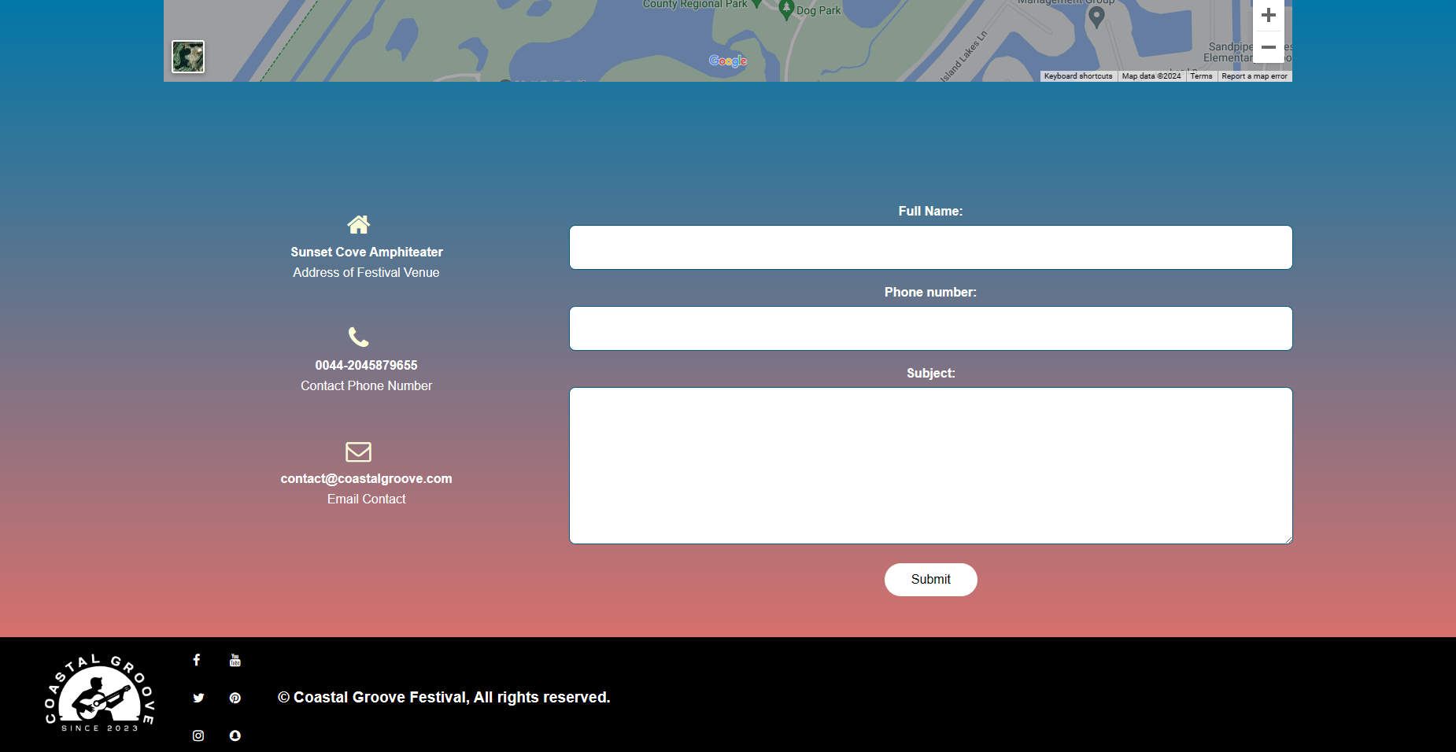

1. **W3C Standards Conformance**

The Coastal Groove Festival website conforms to W3C standards, ensuring a high level of compatibility and accessibility. This compliance was verified using the W3C online validator. The validation process ensures that the HTML, CSS, and JavaScript code adhere to established web standards, promoting cross-browser compatibility and improved user experience.

The validation for the landing page: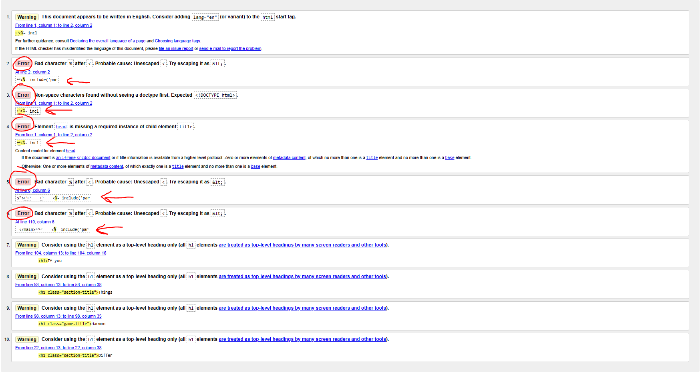

**All of the “errors” in this snapshot are a result of me using ejs templating and not actual html errors.**

The validation for the lineup page:

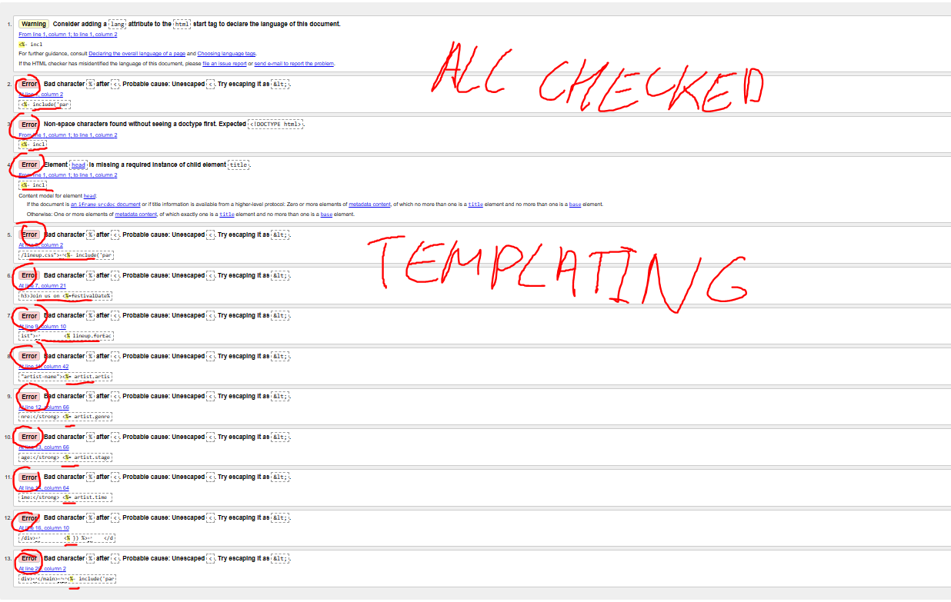

**Again all of the “errors” are the result of the html validator not recognizing ejs symbols and templating.**

The validation for the stages page: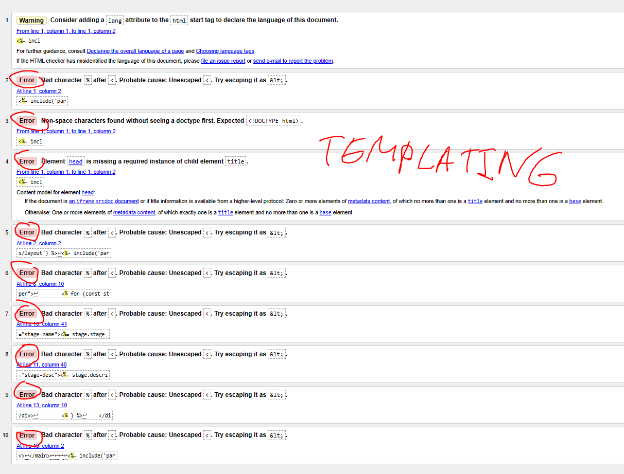

All the errors are checked and are the same as before.

The validation for the faq page:

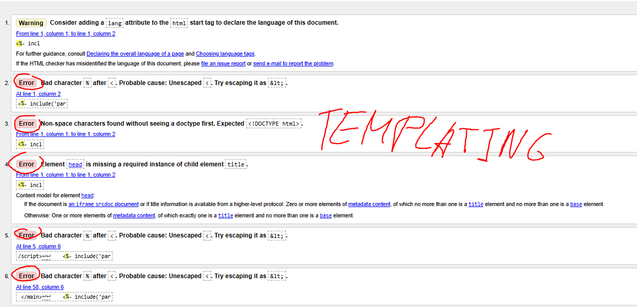

All errors are checked and are because of ejs.

The validation for the game/activity page:

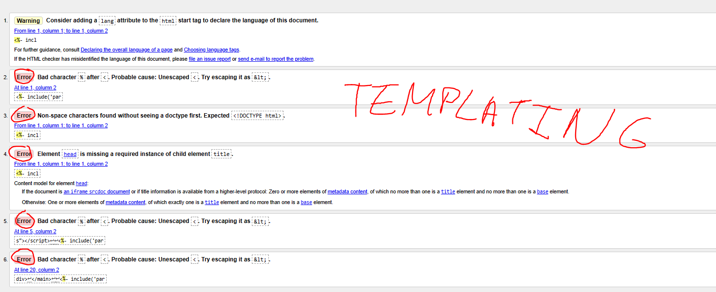

All errors are because of ejs.

The validation for the contact page:

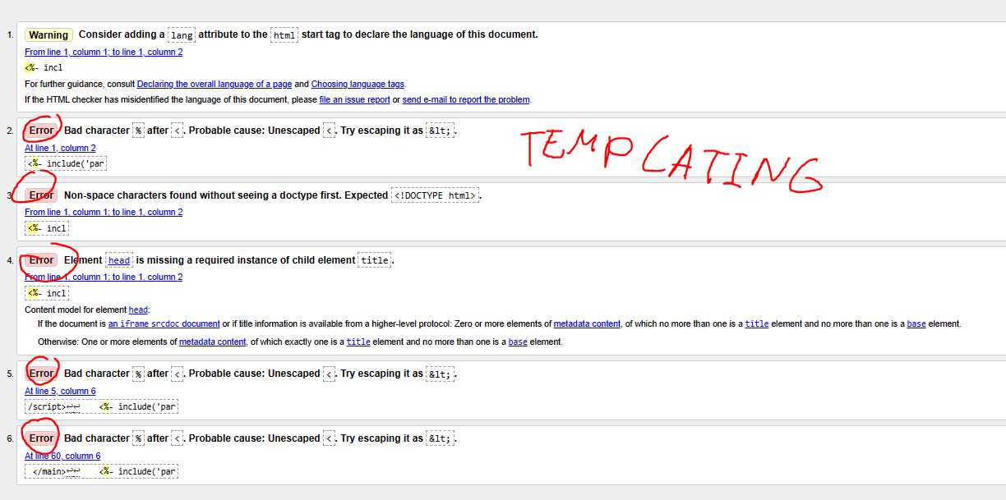

Same errors as before.

Therefore every single page conforms to the W3C standards as they have no real html errors.

1. **Compatibility for different browsers**

My Website works on Chrome, Edge and Firefox.

On Chrome: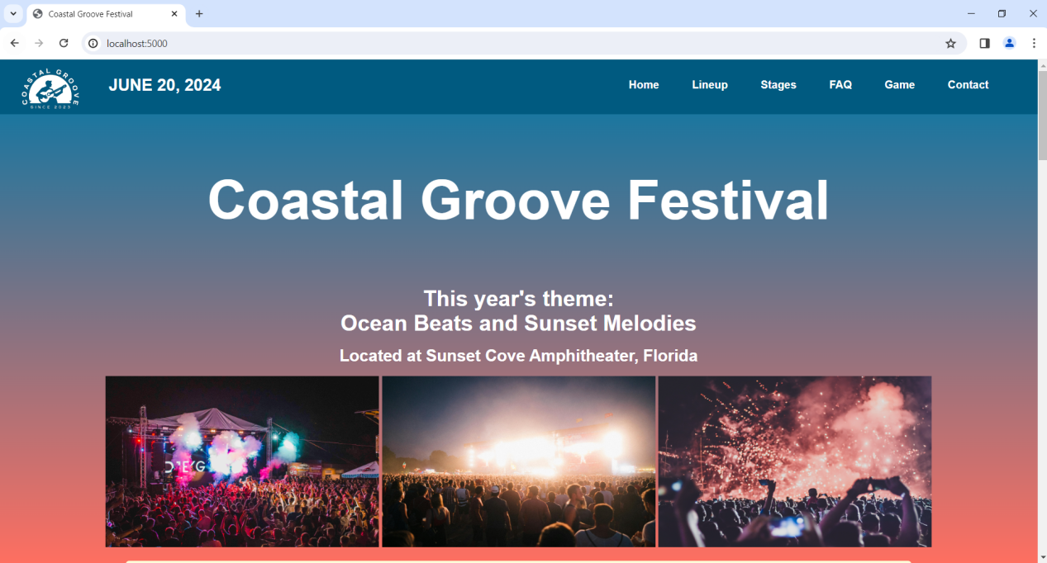

On Edge:

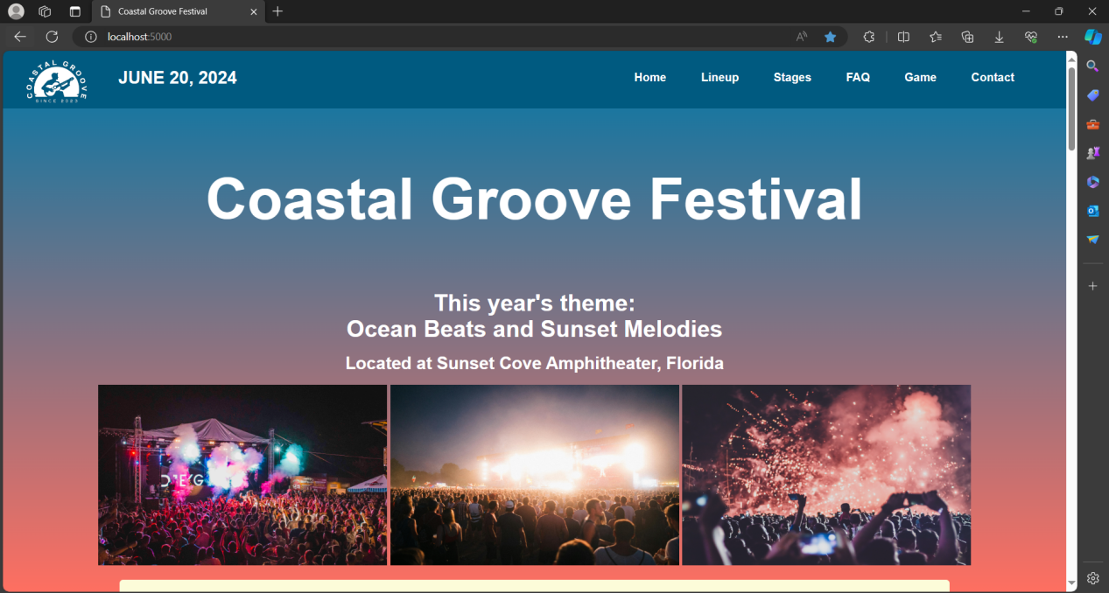

On Firefox: 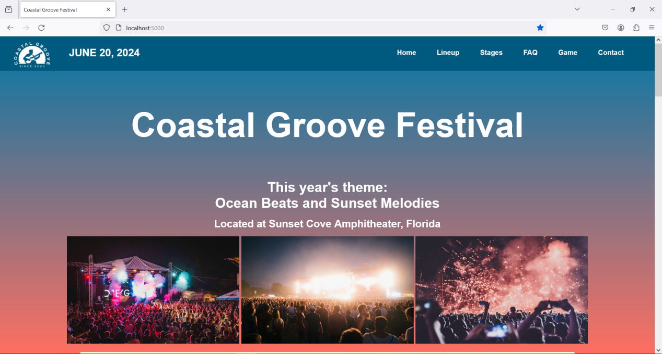

There are no errors in the console on any page of my project.

1. **Database-Related Feature Explanation**

**Contact Form Explanation**

**1. Client-Side (Frontend):**

*HTML Form:* The contact form is presented to the user through HTML. It includes input fields for name, phone number, and subject.

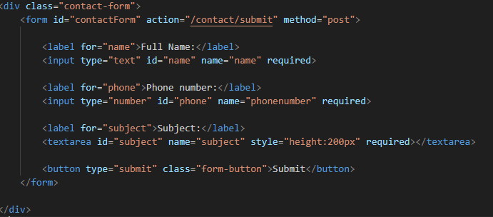

*CSS Styling*: Client-side styling (CSS) is applied to enhance the visual presentation and layout of the form.

**2.Server-Side (Backend):**

*Express.js Route*: The form data is submitted to the server through an Express.js route on the backend. This route is responsible for handling the form submission.

*Database Interaction*: On the server side, there's interaction with the database (SQLite in this case). The backend retrieves the festival database's path and uses SQLite to open a connection.

My route contact.js file:

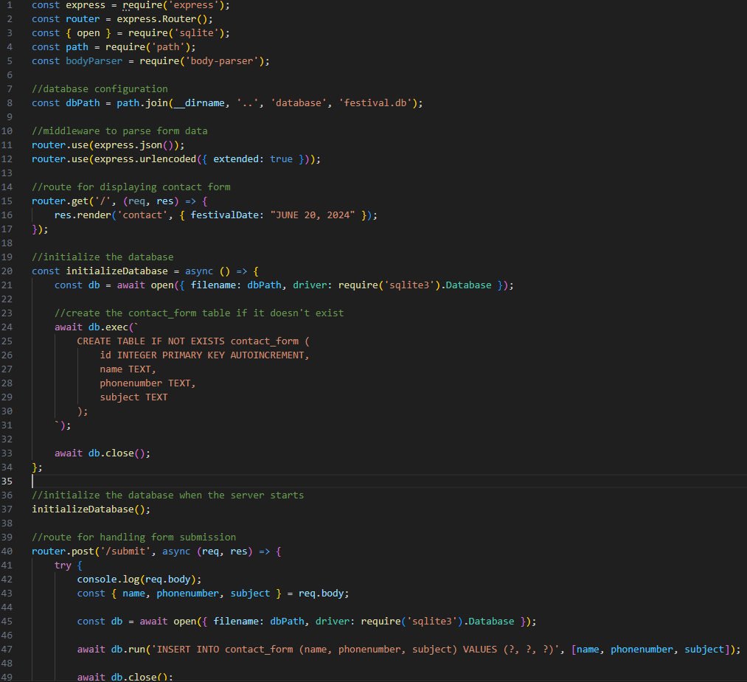

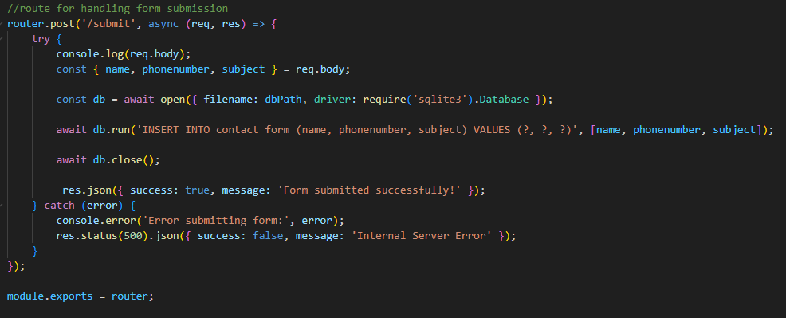

*Form Data Processing*: The server extracts form data (name, phone number, subject) from the submitted form and processes it.

*Data Insertion into Database*: The processed data is then inserted into the database. In this case, it is the contact_form table.

*Error Handling*: If any errors occur during the database interaction or form processing, appropriate error messages are logged, and an internal server error response (HTTP status code 500) is sent to the client.

**3. Client-Side (Response):**

*Response Handling*: The client receives a response from the server. If the form submission is successful, a success message is displayed to the user. If there's an error, an error message is displayed, indicating that there was an internal server error.

My contact.js script:

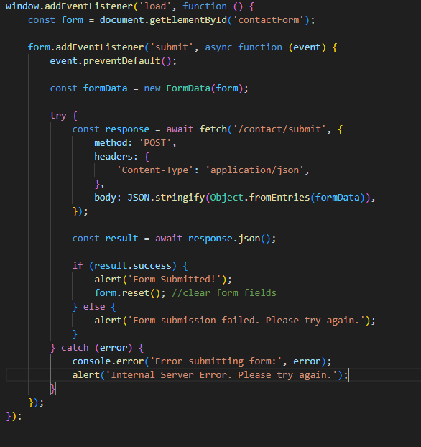

1. **Legal and Ethical Considerations**

*Image Sourcing*: All images used in the festival website have been sourced from reputable platforms that provide royalty-free images. Every single image has been either from the website Pexels or Unsplash, which are stock image websites. The Logo of the website has been created by me.

1. **Accessibility**

*Alternative Text for Images*: All images on the website include descriptive alt text. This enhances accessibility for users with visual impairments, providing meaningful descriptions of visual content.

*Semantic HTML*: Proper use of semantic HTML tags ensures a logical structure, contributing to screen reader compatibility.

1. **Security Considerations**

*Database Security*: The SQLite database is securely configured. It follows best practices to prevent SQL injection and unauthorized access.

1. **Responsiveness of the website**

I have created the site so it’s accessible to people with lower display resolutions (phones and tablets).

Normal view for phones (in this specific example IPhone XR):

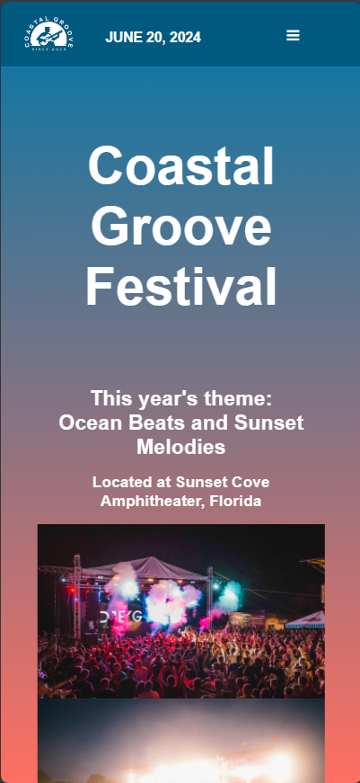

The same view with the menu opened:

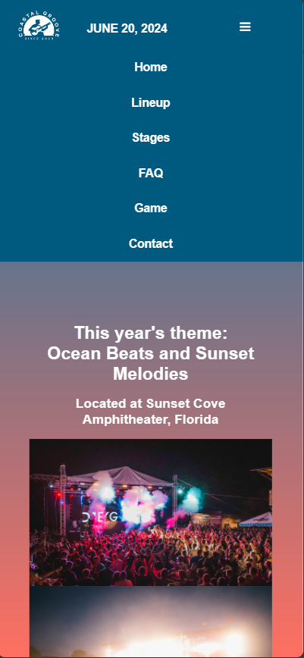

The Website as displayed on tablets (in this example specifically iPad Air):

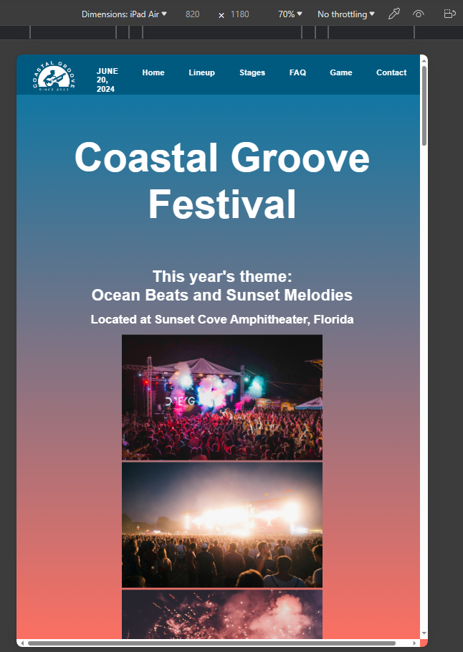

The code I used for the responsiveness of the navigation bar and the footer:

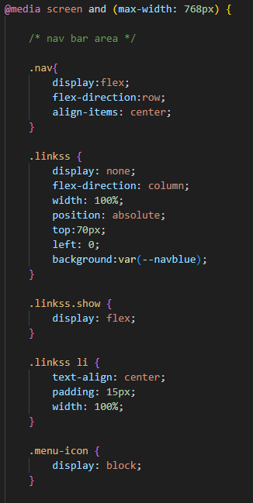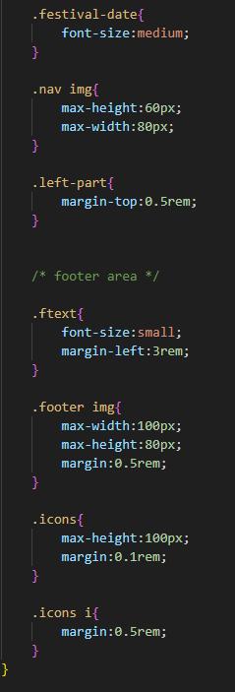

The project also has separate css for responsiveness for each page.

In conclusion, the Coastal Groove Festival website adheres to web standards, incorporates interactive database-driven features, and upholds legal, ethical, and accessibility considerations.